Members shape (raw): (300, 10)
Workouts shape (raw): (4099, 9)
Merged dataset shape (clean): (4099, 30)
Data dictionary saved with 31 rows.
\nBasic descriptive statistics for key numeric fields:
duration_min calories_burned BMI avg_heart_rate tenure_days
count 4099.000000 4099.000000 4099.000000 4099.000000 4099.000000
mean 54.122469 388.707038 26.411067 130.151134 174.016345
std 14.200359 184.878184 5.752488 14.799875 99.925724
min 10.000000 0.600000 9.202915 76.900000 0.000000
25% 45.000000 288.650000 23.141350 120.400000 90.000000
50% 54.000000 367.400000 26.404593 130.300000 174.000000
75% 63.000000 451.750000 30.043481 140.000000 254.000000
max 110.000000 1684.300000 51.817602 185.900000 364.000000

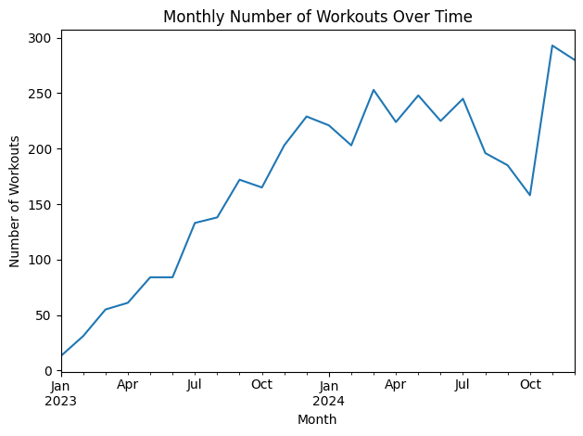
Caption: The number of recorded workouts generally increases over time, reflecting higher engagement as the gym membership base grows.

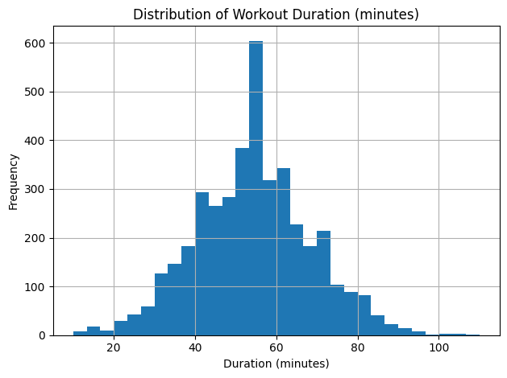
Caption: Workout durations cluster around 45–70 minutes, with relatively few very short or very long sessions after cleaning.

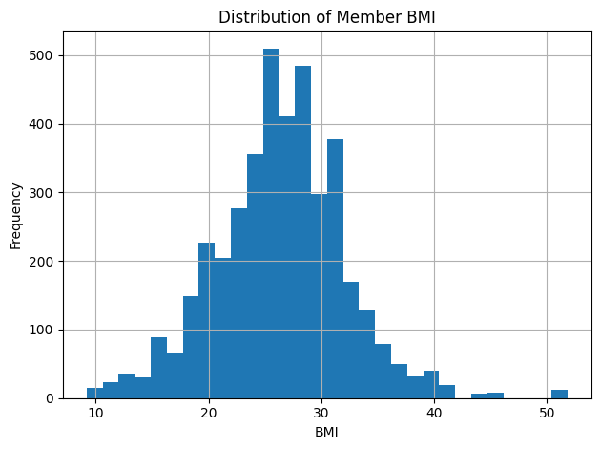
Caption: Most members fall in the overweight to moderately obese BMI range, with a smaller group in the normal range.

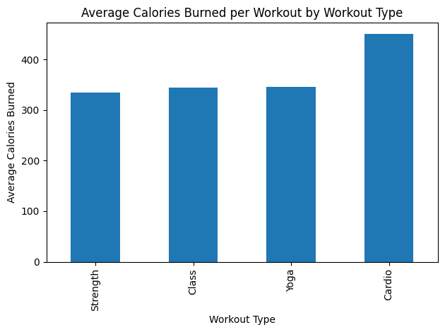
Caption: Cardio sessions burn the most calories on average, while Yoga sessions burn the least, as expected.

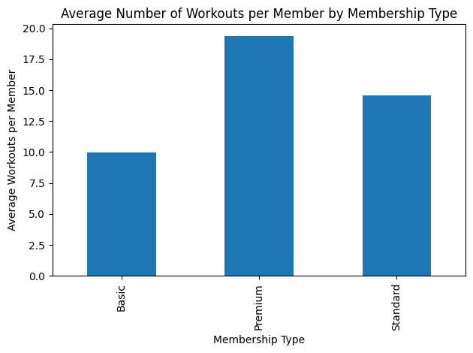
Caption: Premium members work out more frequently on average than Basic and Standard members.

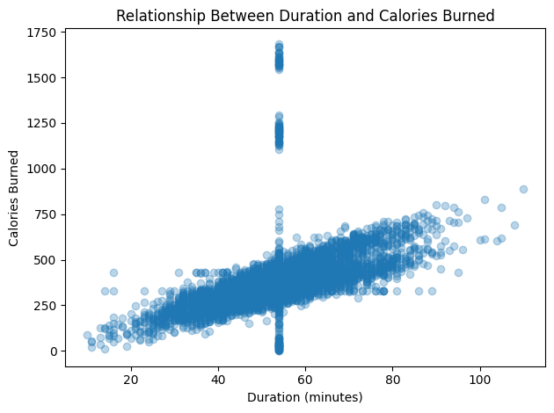
Caption: There is a clear positive relationship between workout duration and calories burned, with more variation at longer durations.

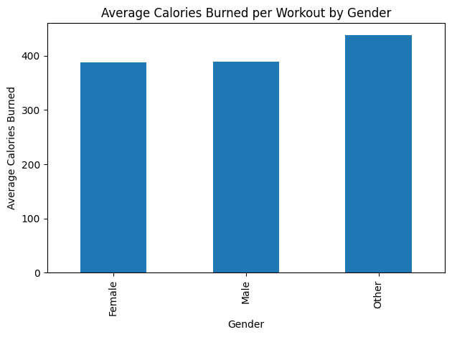
Caption: Male and Female members burn similar calories per session, with slight differences that may reflect fitness level or workout preferences.

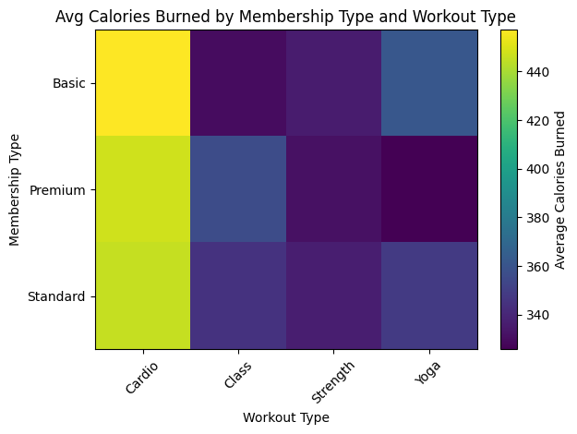
Caption: Across all workout types, Premium members tend to burn slightly more calories per session, reflecting longer or more intense workouts.

<Figure size 640x480 with 0 Axes>
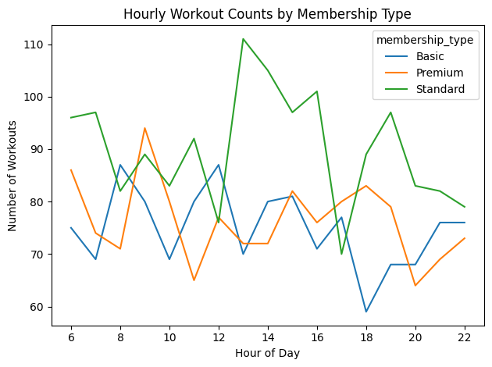
Caption: All membership types favor evening workouts, but Premium members have relatively more sessions in off-peak daytime hours.
\nReshaped long-form sample:
member_id metric value
0 1 BMI 26.35605
1 1 BMI 26.35605
2 1 BMI 26.35605
3 1 BMI 26.35605
4 1 BMI 26.35605

